

**ALI MABRUR MUBAROK**

**210511112**

**/ TIF21C**

|  |  |
| --- | --- |
| NAMA | : ARYA SUBHANDHI |
| NIM | : 210511107 |
| Kelas | : TIF21C / R3 |
| Tugas | : 2 / Praktikum |

1. Single1.py, Single2.py

Single1.py =

#Nama : ARYA SUBHANDHI

#Nim : 210511107

#Kelas : TIF21C

class Karyawan: def __init__(self, nama, jenis):

self.nama = nama

self.jenis = jenis

def misi(self):

print(f"{self.nama} sedang menjalankan misi.")

class Kerjaan(Karyawan):

def __init__(self, nama, jenis, status): super().__init__(nama, jenis) self.status = status

def cuti(self):

print(f"{self.nama} sebagai {self.jenis} sedang cuti.")

kerja1 = Kerjaan("Sujiwo", "teknisi", "karyawan") kerja1.misi() kerja1.cuti()

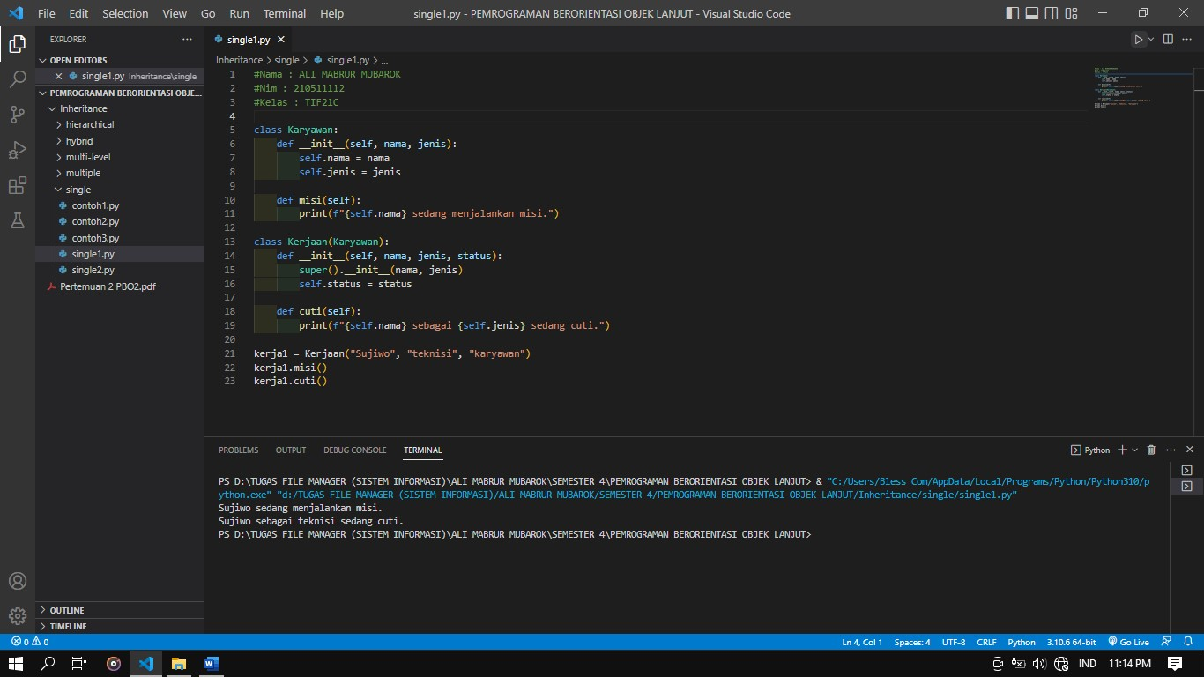

Single2.py =

#Nama : ARYA SUBHANDHI

#Nim : 210511107

#Kelas : TIF21C

class Rumahsakit: def __init__(self, nama, alamat):

self.nama = nama self.alamat = alamat

def dirawat(self):

print(self.nama, "sedang dirawat")

class Pasien(Rumahsakit):

def __init__(self, nama, alamat, penyakit):

super().__init__(nama, alamat) self.penyakit = penyakit

def pulang(self): print(self.nama, "telah dipulangkan")

pasien1 = Pasien("naruto", "konoha", "asamlambung") pasien1.dirawat() pasien1.pulang()

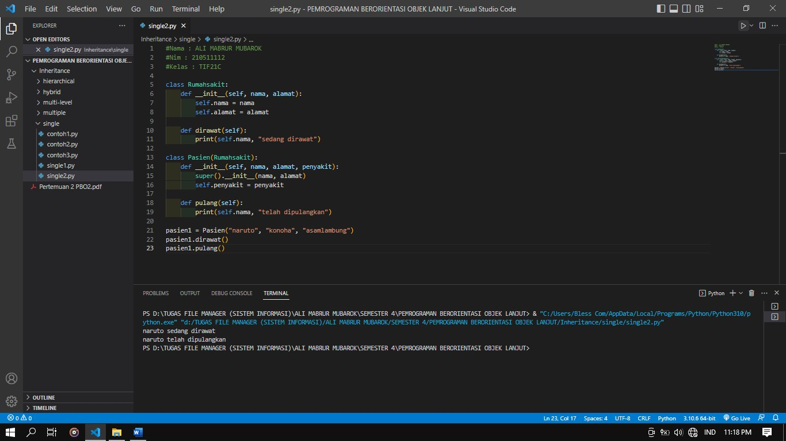

2. Multiple1.py, Multiple2.py

Multiple1.py =

#Nama : ARYA SUBHANDHI

#Nim : 210511107

#Kelas : TIF21C

class tumbuhan:

def __init__(self, nama, tipe):

self.nama = nama

self.tipe = tipe

def display_info(self): print(f"Nama: {self.nama}") print(f"Type: {self.tipe}")

class berbuah: def __init__(self, daun, batang):

self.daun = daun self.batang = batang

def display_info(self):

print(f"Daun: {self.daun}") print(f"Batung: {self.batang}")

class berbiji: def __init__(self, akar, bunga):

self.akar = akar self.bunga = bunga

def display_info(self): print(f"Akar: {self.Akar}") print(f"Bunga: {self.Bunga}")

class Mangga(tumbuhan, berbuah, berbiji): def __init__(self, nama, tipe, daun, batang, akar, bunga):

tumbuhan.__init__(self, nama, tipe) berbuah.__init__(self, daun, batang) berbiji.__init__(self, akar, bunga)

def display_info(self): super().display_info() print(f"Daun: {self.daun}") print(f"Batang: {self.batang}") print(f"Akar: {self.akar}") print(f"Bunga: {self.bunga}")

tumbuhan1 = Mangga("Mangga", "buah", "hijau", "kasar", "serabut", "kuning") tumbuhan1.display_info()

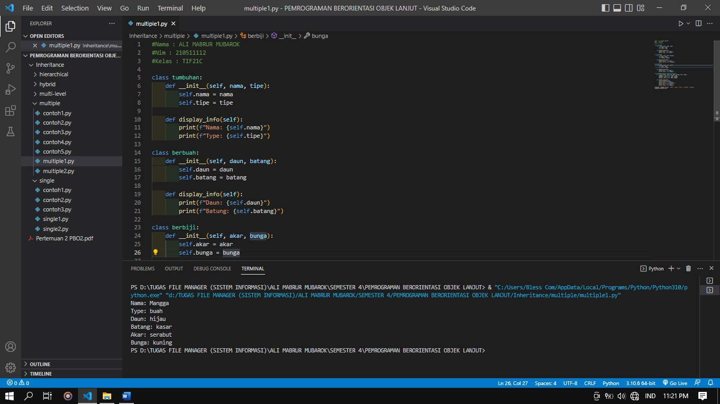

Multiple2.py =

#Nama : ARYA SUBHANDHI

#Nim : 210511107

#Kelas : TIF21C

class pakaian:

def __init__(self, nama, merk):

self.nama = nama self.merk = merk

def display_info(self):

print(f"Nama: {self.nama}") print(f"Merk dari: {self.merk}")

class panjang: def __init__(self, ukuran, bahan):

self.ukuran = ukuran self.bahan = bahan

def display_info(self):

print(f"Ukuran: {self.ukuran}") print(f"Bahan: {self.bahan}")

class pendek: def __init__(self, genre, harga):

self.genre = genre self.harga = harga

def display_info(self):

print(f"Genre: {self.genre}") print(f"Harga: {self.harga}")

class Adidas(pakaian, panjang, pendek): def __init__(self, nama, merk, ukuran, bahan, genre, harga):

pakaian.__init__(self, nama, merk) panjang.__init__(self, ukuran, bahan) pendek.__init__(self, genre, harga)

def display_info(self): super().display_info() print(f"Ukurannya: {self.ukuran}") print(f"Bahan: {self.bahan}") print(f"Genrenya: {self.genre}") print(f"Harga senilai: {self.harga}")

Baju1 = Adidas("Baju", "Carvil", 67, "katun", "santai", 200000) Baju1.display_info()

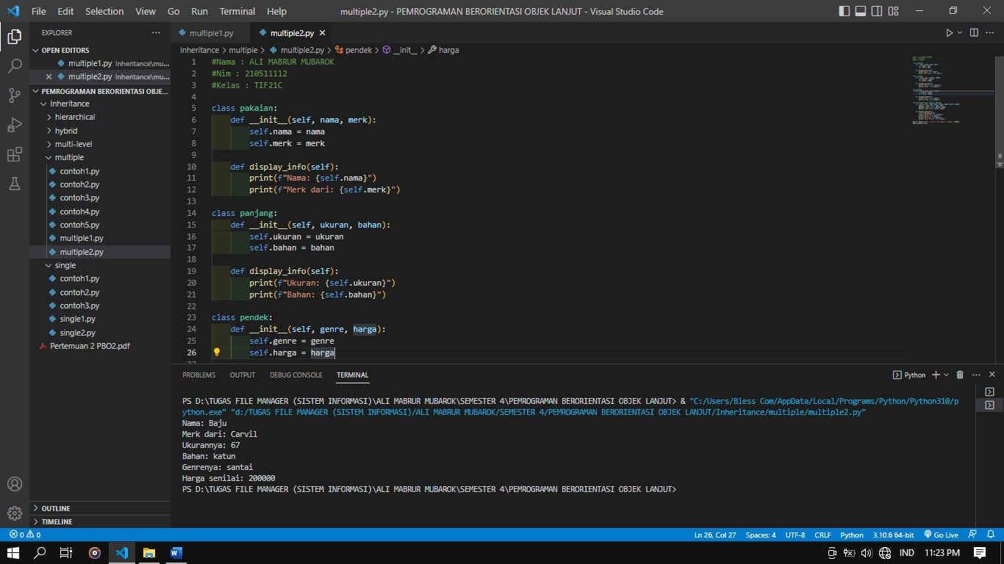

3. Hierarchical1.py , Hierarchical2.py

Hierarchical1.py =

#Nama = ARYA SUBHANDHI

#Nim = 210511107

#Kelas = TIF21C / R3

class Tumbuhan:

def __init__(self, nama, warna):

self.nama = nama self.warna = warna

def get_nama(self): return self.nama

def get_warna(self): return self.warna

class berbiji(Tumbuhan): def __init__(self, nama, warna, biji): super().__init__(nama, warna)

self.biji = biji

def get_biji(self): return self.biji

class berbuah(Tumbuhan): def __init__(self, nama, warna, buah): super().__init__(nama, warna) self.buah = buah

def get_buah(self): return self.buah

# Hierarchical Inheritance class Semangka(berbuah): def __init__(self, nama, warna, buah, batang):

super().__init__(nama, warna, buah) self.batang = batang

def get_batang(self):

return self.batang

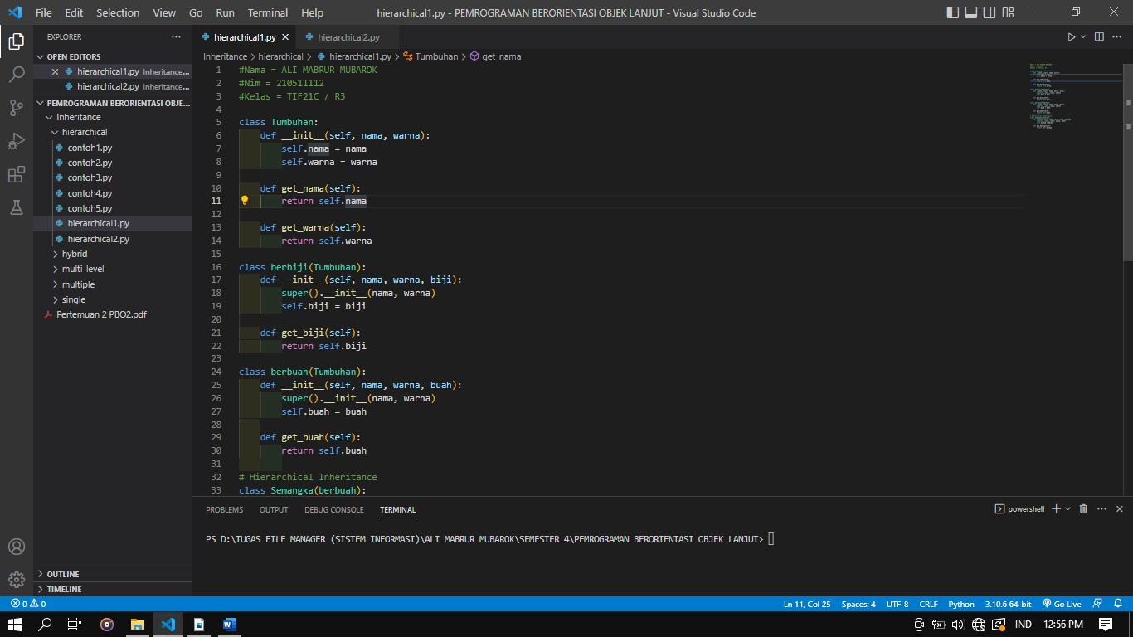

Hierarchical2.py =

#Nama = ARYA SUBHANDHI

#Nim = 210511107

#Kelas = TIF21C / R3

class AkunShopee: def __init__(self, nomor_akun, alamat):

self.nomor_akun = nomor_akun self.alamat = alamat

def get_nomor_akun(self):

return self.nomor_akun

def get_alamat(self): return self.alamat

class AkunTopup(AkunShopee): def __init__(self, nomor_akun, alamat, topup): super().__init__(nomor_akun, alamat) self.topup = topup

def get_topup(self): return self.topup

class Akunchekout(AkunShopee): def __init__(self, nomor_akun, alamat, chekout):

super().__init__(nomor_akun, alamat) self.chekout = chekout

def get_checkout(self): return self.chekout

# Hierarchical Inheritance class Pembeli(Akunchekout): def __init__(self, nomor_akun, alamat, chekout, tujuan): super().__init__(nomor_akun, alamat, chekout) self.tujuan = tujuan

def get_tujuan(self): return self.tujuan

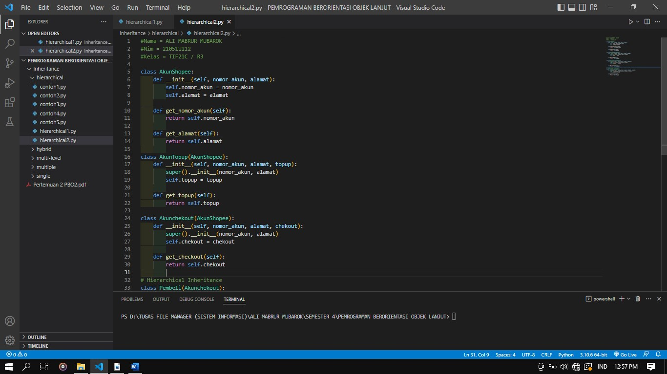

4. Multi-level1.py , Multi-level2.py

Multi-level1.py =

#Nama = ARYA SUBHANDHI

#Nim = 210511107

#Kelas = TIF21C / R3

class Tumbuhan:

def __init__(self, name):

self.name = name

def fotosintesis(self):

print("Tumbuhan ini sedang Fotosintesis")

class Berbatang(Tumbuhan): def __init__(self, name, kayu):

super().__init__(name) self.kayu = kayu

def kayu(self):

print("Tumbuhan berkayu")

class Mangga(Berbatang): def __init__(self, name, kayu, buah):

super().__init__(name, kayu) self.buah = buah

def buah(self): print("Tumbuhan ini berbuah")

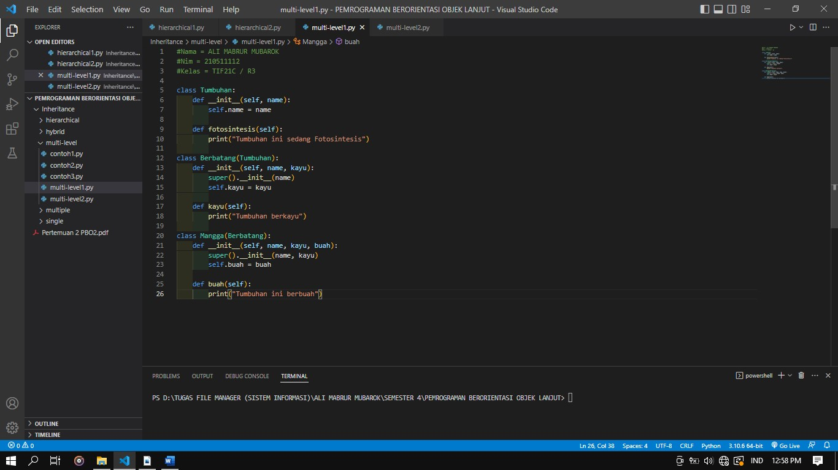

Multi-level2.py =

#Nama = ARYA SUBHANDHI

#Nim = 210511107

#Kelas = TIF21C / R3

class Negara:

def __init__(self, name, flag):

self.name = name self.flag = flag

def get_details(self):

print(f"Name: {self.name}, Flag: {self.flag}")

class Pemerintah(Negara): def __init__(self, name, flag, lembaga, department):

super().__init__(name, flag) self.lembaga = lembaga self.department = department

def get_details(self): super().get_details()

print(f"Lembaga: {self.lembaga}, Department: {self.department}")

class PSSI(Pemerintah):

def __init__(self, name, flag, lembaga, department, fifa_banned):

super().__init__(name, flag, lembaga, department) self.fifa_banned = fifa_banned

def get_details(self):

super().get_details() print(f"This country is: {self.fifa_banned}")

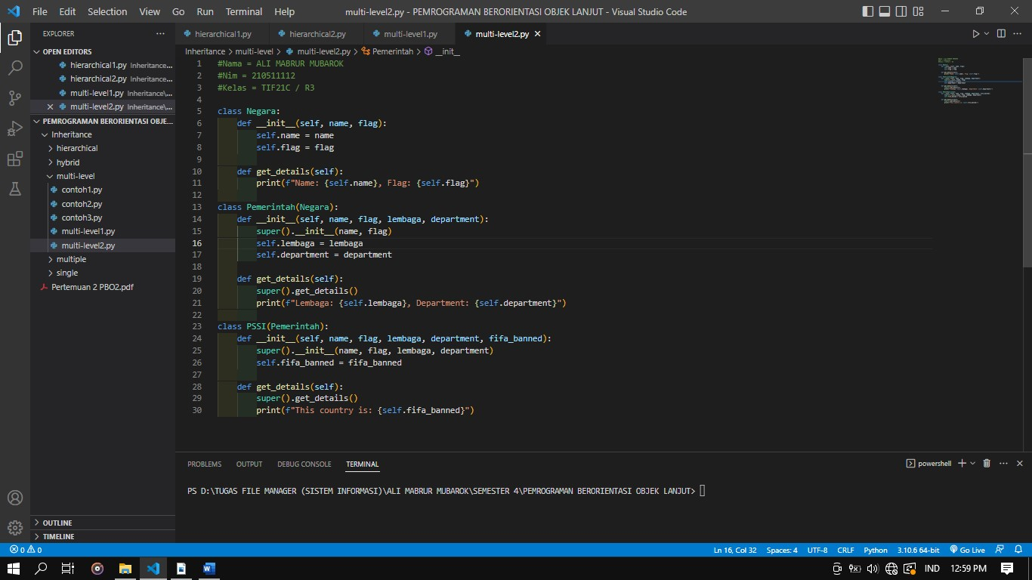

5. Hybrid1.py , Hybrid2.py

Hybrid1.py =

#Nama = ARYA SUBHANDHI

#Nim = 210511107

#Kelas = TIF21C / R3

class Seseorang:

def __init__(self, name, umur, gender):

self.name = name self.umur = umur self.gender = gender

def get_info(self):

print("Name:", self.name) print("Umur:", self.umur) print("Jenis Kelamin:", self.gender) # Single Inheritance class Pejabat(Seseorang): def __init__(self, name, umur, gender, NIP): super().__init__(name, umur, gender) self.NIP = NIP

def get_info(self): super().get_info() print("NIP:", self.NIP)

# Single Inheritance class Aparat(Seseorang): def __init__(self, name, umur, gender, kode_aparat, pangkat):

super().__init__(name, umur, gender) self.kode_aparat = kode_aparat self.pangkat = pangkat

def get_info(self): super().get_info() print("Kode Aparat:", self.kode_aparat) print("Pangkat:", self.pangkat)

# Multiple Inheritance class Tni(Aparat, Pejabat): def __init__(self, name, umur, gender, kode_aparat, pangkat, NIP, perwira):

Aparat.__init__(self, name, umur, gender, kode_aparat, pangkat) Pejabat.__init__(self, name, umur, gender, NIP) self.perwira = perwira

def get_info(self): super().get_info() print("Pangkat:", self.pangkat)

print("kode:", self.kode_aparat)

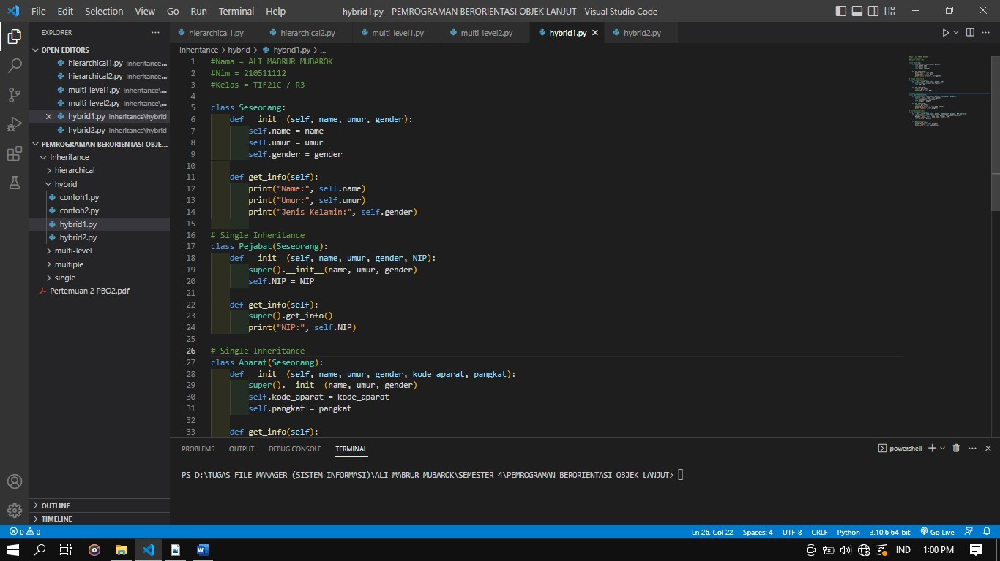

Hybrid2.py =

#Nama = ARYA SUBHANDHI

#Nim = 210511107

#Kelas = TIF21C / R3

class Tumbuhan: def __init__(self, name, age, color):

self.name = name self.age = age self.color = color

def get_info(self):

print("Name:", self.name)

print("Age:", self.age) print("Color:", self.color)

# Single Inheritance class Berbatang(Tumbuhan): def __init__(self, name, age, color, berkayu):

super().__init__(name, age, color) self.berkayu = berkayu

def get_info(self): super().get_info() print("Berbatang:", self.berkayu)

# Single Inheritance class Berongga(Tumbuhan): def __init__(self, name, age, color, jenis, daun):

super().__init__(name, age, color)

self.jenis = jenis self.daun = daun

def get_info(self): super().get_info() print("jenis :", self.jenis) print("Berdaun :", self.daun)

# Multiple Inheritance class Padi(Berongga, Berbatang):

def __init__(self, name, age, color, jenis, daun, berkayu, panen):

Berongga.__init__(self, name, age, color, jenis, daun) Berbatang.__init__(self, name, age, color, berkayu) self.panen = panen

def get_info(self): super().get_info() print("Berbatang :", self.berkayu) print("Dipanen Pada :", self.panen)

